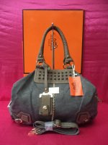

NEW ARRIVALS QUAD A / 4 A HERMES RUGGED 2 IN 1 SATCHEL BAG (CODE 752)GRAY
Category: Bags
Manufacturer: Hermes
Price: Php 825.00
NO MINIMUM ORDER REQUIRED DIMENSIONS:
HEIGHT:11.9 INCHES
WIDTH:13.3 INCHES
DEPTH:6 INCHES

DESCRIPTION:
- SOFT LEATHER MATERIAL
- LIGHT WEIGHT CHAINS
- WITH EXTRA STRAP
DEFINITELY, THIS SEASON'S MUST HAVE :)

NOTE:HERMES BOX & HERMES PAPER BAG NOT INCLUDED

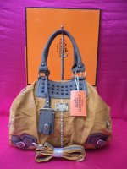

NEW ARRIVALS QUAD A / 4 A HERMES RUGGED 2 IN 1 SATCHEL BAG (CODE 752) TAN
Category: Bags
Manufacturer: Hermes
Price: Php 825.00
NO MINIMUM ORDER REQUIRED

DIMENSIONS:
HEIGHT:11.9 INCHES
WIDTH:13.3 INCHES
DEPTH:6 INCHES

DESCRIPTION:
- SOFT LEATHER MATERIAL
- LIGHT WEIGHT CHAINS
- WITH EXTRA STRAP
DEFINITELY, THIS SEASON'S MUST HAVE :)

NOTE:HERMES BOX & HERMES PAPER BAG NOT INCLUDED
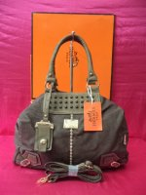

NEW ARRIVALS QUAD A / 4 A HERMES RUGGED 2 IN 1 SATCHEL BAG (CODE 752) COFFEE BROWN
Category: Bags
Manufacturer: Hermes
Price: Php 825.00
NO MINIMUM ORDER REQUIRED

DIMENSIONS:
HEIGHT:11.9 INCHES
WIDTH:13.3 INCHES
DEPTH:6 INCHES

DESCRIPTION:
- SOFT LEATHER MATERIAL
- LIGHT WEIGHT CHAINS
- WITH EXTRA STRAP
DEFINITELY, THIS SEASON'S MUST HAVE :)

NOTE:HERMES BOX & HERMES PAPER BAG NOT INCLUDED

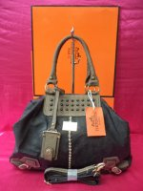

NEW ARRIVALS QUAD A / 4 A HERMES RUGGED 2 IN 1 SATCHEL BAG (CODE 752) BLACK
Category: Bags
Manufacturer: Hermes
Price: Php 825.00
NO MINIMUM ORDER REQUIRED

DIMENSIONS:
HEIGHT:11.9 INCHES
WIDTH:13.3 INCHES
DEPTH:6 INCHES

DESCRIPTION:
- SOFT LEATHER MATERIAL
- LIGHT WEIGHT CHAINS
- WITH EXTRA STRAP
DEFINITELY, THIS SEASON'S MUST HAVE :)

NOTE:HERMES BOX & HERMES PAPER BAG NOT INCLUDED
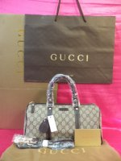

OUR BEST SELLER SUPER AA 8 STAR EURO REPLICA GUCCI PATENT LEATHER BROWN MONOGRAM DOCTORS BAG (CODE 203696)
Category: Bags
Manufacturer: Gucci
Price: Php 2,350.00
NO MINIMUM ORDER REQUIRED

DESCRIPTION:
- PURE LEATHER DETAILING
- REPLICA MATERIAL CANVAS MATERIAL
DIMENSIONS:
HEIGHT:8.1 INCHES
WIDTH:12.2 INCHES
DEPTH:7 INCHES

INCLUSIONS:
- 8 STAR GUCCI DUST BAG
- 8 STAR GUCCI CERTIFICATES
- GUCCI BOX (OPTIONAL)
- GUCCI PAPER BAG (OPTIONAL) (NOTE:GUCCI PAPER BAG FOR SALE IS LIGHT BROWN NOT DARK BROWN)
NOTE:GUCCI BOX & GUCCI PAPER BAG NOT INCLUDED
.
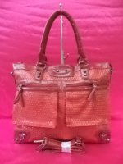

NEW ARRIVALS QUAD A / 4 A BALENCIAGA GIANT WEAVE TOTE BAG (RED)
Category: Bags
Manufacturer: Balenciaga
Price: Php 900.00
NO MINIMUM ORDER REQUIRED

DESCRIPTION:
- SOFT LEATHER MATERIAL
- BELONGS TO 2013 FALL COLLECTION
DIMENSIONS:
HEIGHT:12.2 INCHES
WIDTH:15.8 INCHES
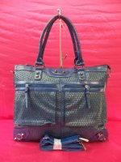

NEW ARRIVALS QUAD A / 4 A BALENCIAGA GIANT WEAVE TOTE BAG (BLUE)
Category: Bags
Manufacturer: Balenciaga
Price: Php 550.00
NO MINIMUM ORDER REQUIRED

DESCRIPTION:
- SOFT LEATHER MATERIAL
- BELONGS TO 2013 FALL COLLECTION
DIMENSIONS:
HEIGHT:12.2 INCHES
WIDTH:15.8 INCHES
More...
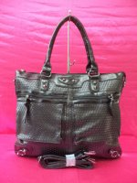

NEW ARRIVALS QUAD A / 4 A BALENCIAGA GIANT WEAVE TOTE BAG (BLACK)
Category: Bags
Manufacturer: Balenciaga
Price: Php 550.00
NO MINIMUM ORDER REQUIRED

DESCRIPTION:
- SOFT LEATHER MATERIAL
- BELONGS TO 2013 FALL COLLECTION
DIMENSIONS:
HEIGHT:12.2 INCHES
WIDTH:15.8 INCHES

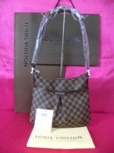

NEW ARRIVALS SUPER AA 8 STAR EURO REPLICA LOUIS VUITTON DAMIER EBENE BLOOMSBERRY MM (CODE N42251)
Category: Bags
Manufacturer: Louis Vuitton
Price: Php 1,650.00
NO MINIMUM ORDER REQUIRED

DIMENSIONS:
HEIGHT:9.3 INCHES
WIDTH:9.3 INCHES
DEPTH:2.7 INCHES

DESCRIPTION:
- OXIDIZED LEATHER
- VERY EXACT COPY
- WITH SERIAL NUMBER
- LATEST MODEL & VERY HOT ITEM

INCLUSIONS:
- LOUIS VUITTON PAPER BAG
- LOUIS VUITTON HIGH QUALITY DUST BAG
- LOUIS VUITTON CERTIFICATE
More...
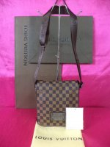

NEW ARRIVALS SUPER AA 8 STAR EURO REPLICA LOUIS VUITTON DAMIER EBENE BROOKLYN MM (CODE N51210)
Category: Bags
Manufacturer: Louis Vuitton
Price: Php 1,500.00
NO MINIMUM ORDER REQUIRED

DIMENSIONS:
HEIGHT:9.3 INCHES
WIDTH:9.3 INCHES
DEPTH:2.7 INCHES

DESCRIPTION:
- OXIDIZED LEATHER
- VERY EXACT COPY
- WITH SERIAL NUMBER
- LATEST MODEL & VERY HOT ITEM

INCLUSIONS:
- LOUIS VUITTON PAPER BAG
- LOUIS VUITTON HIGH QUALITY DUST BAG
- LOUIS VUITTON CERTIFICATE
More...
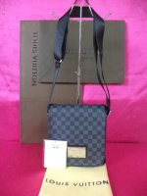

NEW ARRIVALS SUPER AA 8 STAR EURO REPLICA LOUIS VUITTON DAMIER GRAPHITE BROOKLYN MM (CODE N51210)
Category: Bags
Manufacturer: Louis Vuitton
Price: Php 1,650.00
NO MINIMUM ORDER REQUIRED

DIMENSIONS:
HEIGHT:9.3 INCHES
WIDTH:9.3 INCHES
DEPTH:2.7 INCHES

DESCRIPTION:
- OXIDIZED LEATHER
- VERY EXACT COPY
- WITH SERIAL NUMBER
- LATEST MODEL & VERY HOT ITEM

INCLUSIONS:
- LOUIS VUITTON PAPER BAG
- LOUIS VUITTON HIGH QUALITY DUST BAG
- LOUIS VUITTON CERTIFICATE
More...
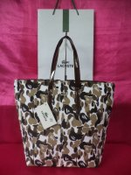

NEW ARRIVALS QUAD A / 4 A LACOSTE CANVAS PRINTS (CODE 196#) COFFEE HANDLE
Category: Bags
Manufacturer: Lacoste
Price: Php 475.00
NO MINIMUM ORDER REQUIRED

DIMENSIONS:
HEIGHT:14.8 INCHES
WIDTH:16.2 INCHES
DEPTH:5.4 INCHES

NOTE:LACOSTE PAPER BAG NOT INCLUDED & NOT FOR SALE
More...
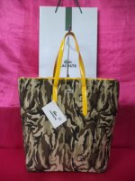

NEW ARRIVALS QUAD A / 4 A LACOSTE CANVAS PRINTS (CODE 196#) YELLOW HANDLE
Category: Bags
Manufacturer: Lacoste
Price: Php 475.00
NO MINIMUM ORDER REQUIRED

DIMENSIONS:
HEIGHT:14.8 INCHES
WIDTH:16.2 INCHES
DEPTH:5.4 INCHES

NOTE:LACOSTE PAPER BAG NOT INCLUDED & NOT FOR SALE
More...
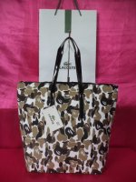

NEW ARRIVALS QUAD A / 4 A LACOSTE CANVAS PRINTS (CODE 196#) BLACK HANDLE
Category: Bags
Manufacturer: Lacoste
Price: Php 475.00
NO MINIMUM ORDER REQUIRED

DIMENSIONS:
HEIGHT:14.8 INCHES
WIDTH:16.2 INCHES
DEPTH:5.4 INCHES

NOTE:LACOSTE PAPER BAG NOT INCLUDED & NOT FOR SALE
More...
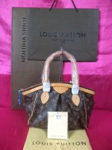

OUR BEST SELLER SUPER AA 8 STAR EURO REPLICA LOUIS VUITTON MONOGRAM CANVAS TIVOLI MM (CODE M40143)
Category: Bags
Manufacturer: Louis Vuitton
Price: Php 1,750.00
NO MINIMUM ORDER REQUIRED

DIMENSIONS:
HEIGHT:9.4 INCHES
WIDTH:13.5 INCHES
DEPTH:6 INCHES

DESCRIPTION:
GENUINE LEATHER
OXIDIZED LEATHER MATERIAL
HIGHEST REPLICA
WITH SERIAL NUMBER

INCLUSIONS:
LOUIS VUITTON CERTIFICATE
LOUIS VUITTON DUST BAG
LOUIS VUITTON PAPERBAG

NOTE:LOUIS VUITTON GIFT BOX NOT INCLUDED
More...
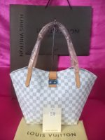

NEW ARRIVALS SUPER AA 8 STAR EURO REPLICA LOUIS VUITTON DAMIER AZUR SALINA (CODE M41208)
Category: Bags
Manufacturer: Louis Vuitton
Price: Php 2,100.00
MINIMUM 3 PIECES IN ASSORTED ALBUMS

DIMENSIONS:
HEIGHT:11 INCHES
WIDTH:17 INCHES
DEPTH:6.6 INCHES

DESCRIPTION:
GENUINE LEATHER
OXIDIZED LEATHER MATERIAL
HIGHEST REPLICA
WITH SERIAL NUMBER

INCLUSIONS:
LOUIS VUITTON CERTIFICATE
LOUIS VUITTON DUST BAG
LOUIS VUITTON PAPERBAG

NOTE:LOUIS VUITTON GIFT BOX NOT INCLUDED
More...
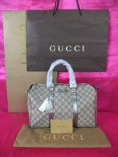

NEW ARRIVALS SUPER AA 8 STAR EURO REPLICA GUCCI JOY SILVER CHROME DETAILING DOCTORS BAG (CODE 193603)
Category: Bags
Manufacturer: Gucci
Price: Php 1,750.00
NO MINIMUM ORDER REQUIRED

DESCRIPTION:
- PURE LEATHER DETAILING
- REPLICA MATERIAL CANVAS MATERIAL
DIMENSIONS:
HEIGHT:10.7 INCHES
WIDTH:13 INCHES
DEPTH:7.8 INCHES

INCLUSIONS:
- 8 STAR GUCCI DUST BAG
- 8 STAR GUCCI CERTIFICATES
- GUCCI BOX (OPTIONAL)
- GUCCI PAPER BAG (OPTIONAL) (NOTE:GUCCI PAPER BAG FOR SALE IS LIGHT BROWN NOT DARK BROWN)
NOTE:GUCCI BOX & GUCCI PAPER BAG NOT INCLUDED

More...
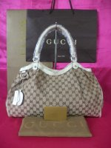

OUR BEST SELLER SUPER AA 8 STAR EURO REPLICA GUCCI MONOGRAM SUKEY GM BAG (WHITE) CODE 211943
Category: Bags
Manufacturer: Gucci
Price: Php 1,750.00
NO MINIMUM ORDER REQUIRED

DESCRIPTION:
- PURE LEATHER DETAILING
- REPLICA MATERIAL CANVAS MATERIAL
DIMENSIONS:
HEIGHT:10 INCHES
WIDTH:16.2 INCHES
DEPTH:6 INCHES

INCLUSIONS:
- 8 STAR GUCCI DUST BAG
- 8 STAR GUCCI CERTIFICATES
- GUCCI BOX (OPTIONAL)
- GUCCI PAPER BAG (OPTIONAL) (NOTE:GUCCI PAPER BAG FOR SALE IS LIGHT BROWN NOT DARK BROWN)
NOTE:GUCCI BOX & GUCCI PAPER BAG NOT INCLUDED

More...
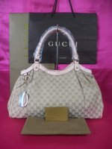

OUR BEST SELLER SUPER AA 8 STAR EURO REPLICA GUCCI MONOGRAM SUKEY GM BAG (PINK) CODE 211943
Category: Bags
Manufacturer: Gucci
Price: Php 1,750.00
NO MINIMUM ORDER REQUIRED
DESCRIPTION:
- PURE LEATHER DETAILING
- REPLICA MATERIAL CANVAS MATERIAL
DIMENSIONS:
HEIGHT:10 INCHES
WIDTH:16.2 INCHES
DEPTH:6 INCHES

INCLUSIONS:
- 8 STAR GUCCI DUST BAG
- 8 STAR GUCCI CERTIFICATES
- GUCCI BOX (OPTIONAL)
- GUCCI PAPER BAG (OPTIONAL) (NOTE:GUCCI PAPER BAG FOR SALE IS LIGHT BROWN NOT DARK BROWN)
NOTE:GUCCI BOX & GUCCI PAPER BAG NOT INCLUDED.
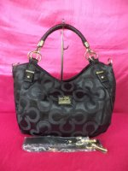

NEW ARRIVALS CLASS A COACH FLORAL EMBOSSED 2 IN 1 SATCHEL BAG (PURE BLACK)
Category: Bags
Manufacturer: Coach
Price: Php 430.00
NO MINIMUM ORDER REQUIRED

DESCRIPTION:
- CANVAS MATERIAL
- LEATHERETTE DETAILING MATERIAL
- CLOTH INTERIOR MATERIAL
DIMENSIONS:
HEIGHT:11.9 INCHES
WIDTH:15.9 INCHES
DEPTH:6 INCHES
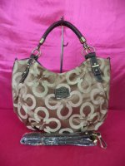

NEW ARRIVALS CLASS A COACH FLORAL EMBOSSED 2 IN 1 SATCHEL BAG (MAHOGANY BROWNS)
Category: Bags
Manufacturer: Coach
Price: Php 430.00
NO MINIMUM ORDER REQUIRED

DESCRIPTION:
- CANVAS MATERIAL
- LEATHERETTE DETAILING MATERIAL
- CLOTH INTERIOR MATERIAL
DIMENSIONS:
HEIGHT:11.9 INCHES
WIDTH:15.9 INCHES
DEPTH:6 INCHES
More...
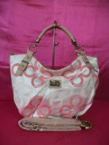

NEW ARRIVALS CLASS A COACH FLORAL EMBOSSED 2 IN 1 SATCHEL BAG (BABY PINKS)
Category: Bags
Manufacturer: Coach
Price: Php 430.00
NO MINIMUM ORDER REQUIRED

DESCRIPTION:
- CANVAS MATERIAL
- LEATHERETTE DETAILING MATERIAL
- CLOTH INTERIOR MATERIAL
DIMENSIONS:
HEIGHT:11.9 INCHES
WIDTH:15.9 INCHES
DEPTH:6 INCHES
More...
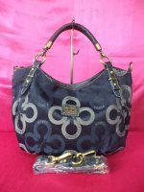

NEW ARRIVALS CLASS A COACH FLORAL EMBOSSED 2 IN 1 SATCHEL BAG (DARK BLUE)
Category: Bags
Manufacturer: Coach
Price: Php 430.00
NO MINIMUM ORDER REQUIRED

DESCRIPTION:
- CANVAS MATERIAL
- LEATHERETTE DETAILING MATERIAL
- CLOTH INTERIOR MATERIAL
DIMENSIONS:
HEIGHT:11.9 INCHES
WIDTH:15.9 INCHES
DEPTH:6 INCHES
More...
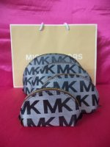

NEW ARRIVALS CLASS A MICHAEL KORS 4 IN 1 HAPPY POUCHES (BLACK)
Category: Bags
Manufacturer: Michael Kors
Price: Php 210.00
NO MINIMUM ORDER REQUIRED

DESCRIPTION:
- CANVAS MATERIAL
- ZIPPY MATERIAL

NOTE:CHANEL PAPERBAG NOT INCLUDED
More...
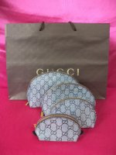

NEW ARRIVALS CLASS A GUCCI MONOGRAM 4 IN 1 HAPPY POUCHES (BLACK)
Category: Bags
Manufacturer: Gucci
Price: Php 210.00
NO MINIMUM ORDER REQUIRED

DESCRIPTION:
- CANVAS MATERIAL
- ZIPPY MATERIAL

NOTE:CHANEL PAPERBAG NOT INCLUDED
More...

NEW ARRIVALS CLASS A CHANEL 4 IN 1 HAPPY POUCHES (BLACK)
Category: Bags
Manufacturer: Chanel
Price: Php 210.00
NO MINIMUM ORDER REQUIRED

DESCRIPTION:
- CANVAS MATERIAL
- ZIPPY MATERIAL

NOTE:CHANEL PAPERBAG NOT INCLUDED
More...
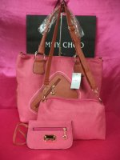

NEW ARRIVALS QUAD A / 4 A JIMMY CHOO 3 IN 1 SATCHEL BAGS (CODE K0091) PINK
Category: Bags
Manufacturer: Jimmy Choo
Price: Php 550.00
NO MINIMUM ORDER REQUIRED

DESCRIPTION:
- SOFT LEATHERETTE MATERIAL
- SPACIOUS BAG

DIMENSIONS:
HEIGHT:13 INCHES
WIDTH:17 INCHES
DEPTH:5 INCHES
More...
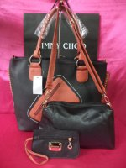

NEW ARRIVALS QUAD A / 4 A JIMMY CHOO 3 IN 1 SATCHEL BAGS (CODE K0091) BLACK
Category: Bags
Manufacturer: Jimmy Choo
Price: Php 550.00
NO MINIMUM ORDER REQUIRED

DESCRIPTION:
- SOFT LEATHERETTE MATERIAL
- SPACIOUS BAG

DIMENSIONS:
HEIGHT:13 INCHES
WIDTH:17 INCHES
DEPTH:5 INCHES
More...
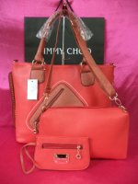

NEW ARRIVALS QUAD A / 4 A JIMMY CHOO 3 IN 1 SATCHEL BAGS (CODE K0091) RED
Category: Bags
Manufacturer: Jimmy Choo
Price: Php 550.00
NO MINIMUM ORDER REQUIRED

DESCRIPTION:
- SOFT LEATHERETTE MATERIAL
- SPACIOUS BAG

DIMENSIONS:
HEIGHT:13 INCHES
WIDTH:17 INCHES
DEPTH:5 INCHES
More...
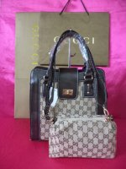

NEW ARRIVALS QUAD A / 4 A GUCCI MONOGRAM SYLVIA 2 IN 1 SATCHEL BAG (CODE 6039) COFFEE
Category: Bags
Manufacturer: Gucci
Price: Php 520.00
NO MINIMUM ORDER REQUIRED

DESCRIPTION:
- HIGH QUALITY CANVAS MATERIAL
- WITH EXTRA STRAPS
- LEATHERETTE MATERIAL DETAILING

DIMENSIONS:
HEIGHT:11.9 INCHES
WIDTH:11.9 INCHES
DEPTH:5.3 INCHES

More...
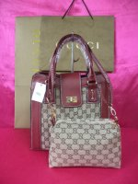

NEW ARRIVALS QUAD A / 4 A GUCCI MONOGRAM SYLVIA 2 IN 1 SATCHEL BAG (CODE 6039) RED
Category: Bags
Manufacturer: Gucci
Price: Php 520.00
NO MINIMUM ORDER REQUIRED

DESCRIPTION:
- HIGH QUALITY CANVAS MATERIAL
- WITH EXTRA STRAPS
- LEATHERETTE MATERIAL DETAILING

DIMENSIONS:
HEIGHT:11.9 INCHES
WIDTH:11.9 INCHES
DEPTH:5.3 INCHES

More...
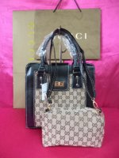

NEW ARRIVALS QUAD A / 4 A GUCCI MONOGRAM SYLVIA 2 IN 1 SATCHEL BAG (CODE 6039) BLACK
Category: Bags
Manufacturer: Gucci
Price: Php 520.00
NO MINIMUM ORDER REQUIRED

DESCRIPTION:
- HIGH QUALITY CANVAS MATERIAL
- WITH EXTRA STRAPS
- LEATHERETTE MATERIAL DETAILING

DIMENSIONS:
HEIGHT:11.9 INCHES
WIDTH:11.9 INCHES
DEPTH:5.3 INCHES

More...
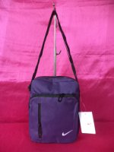

NEW ARRIVALS CLASS A NIKE SLING BAG (PLAIN DARK VIOLET)
Category: Bags
Manufacturer: Nike
Price: Php 180.00
NO MINIMUM ORDER REQUIRED

DESCRIPTION:
- EXACT NIKE STANDARD QUALITY

DIMENSIONS:
HEIGHT:9 INCHES
WIDTH:8 INCHES
DEPTH:3 INCHES

More...
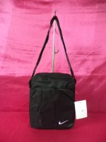

NEW ARRIVALS CLASS A NIKE SLING BAG (PLAIN BLACK)
Category: Bags
Manufacturer: Nike
Price: Php 180.00
NO MINIMUM ORDER REQUIRED

DESCRIPTION:
- EXACT NIKE STANDARD QUALITY

DIMENSIONS:
HEIGHT:9 INCHES
WIDTH:8 INCHES
DEPTH:3 INCHES

More...
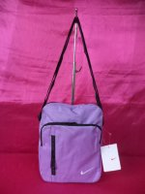

NEW ARRIVALS CLASS A NIKE SLING BAG (PLAIN LILAC)
Category: Bags
Manufacturer: Nike
Price: Php 180.00
NO MINIMUM ORDER REQUIRED

DESCRIPTION:
- EXACT NIKE STANDARD QUALITY

DIMENSIONS:
HEIGHT:9 INCHES
WIDTH:8 INCHES
DEPTH:3 INCHES

More...
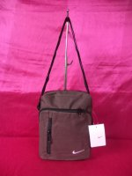

NEW ARRIVALS CLASS A NIKE SLING BAG (PLAIN BROWN)
Category: Bags
Manufacturer: Nike
Price: Php 180.00
NO MINIMUM ORDER REQUIRED

DESCRIPTION:
- EXACT NIKE STANDARD QUALITY

DIMENSIONS:
HEIGHT:9 INCHES
WIDTH:8 INCHES
DEPTH:3 INCHES

More...
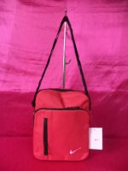

NEW ARRIVALS CLASS A NIKE SLING BAG (PLAIN RED)
Category: Bags
Manufacturer: Nike
Price: Php 180.00
NO MINIMUM ORDER REQUIRED

DESCRIPTION:
- EXACT NIKE STANDARD QUALITY

DIMENSIONS:
HEIGHT:9 INCHES
WIDTH:8 INCHES
DEPTH:3 INCHES

More...
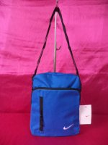

NEW ARRIVALS CLASS A NIKE SLING BAG (PLAIN ROYAL BLUE)
Category: Bags
Manufacturer: Nike
Price: Php 180.00
NO MINIMUM ORDER REQUIRED

DESCRIPTION:
- EXACT NIKE STANDARD QUALITY

DIMENSIONS:
HEIGHT:9 INCHES
WIDTH:8 INCHES
DEPTH:3 INCHES

More...
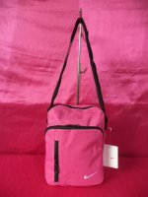

NEW ARRIVALS CLASS A NIKE SLING BAG (PLAIN PINK)
Category: Bags
Manufacturer: Nike
Price: Php 180.00
NO MINIMUM ORDER REQUIRED

DESCRIPTION:
- EXACT NIKE STANDARD QUALITY

DIMENSIONS:
HEIGHT:9 INCHES
WIDTH:8 INCHES
DEPTH:3 INCHES

More...
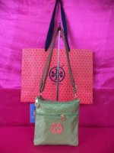

OUR BEST SELLER CLASS A TORY BURCH NYLON SLING BAG (CODE 1206) APPLE GREEN
Category: Bags
Manufacturer: Tory Burch
Price: Php 250.00
NO MINIMUM ORDER REQUIRED

DIMENSIONS:
HEIGHT:8.1 INCHES
WIDTH:8 INCHES

NOTE:TORY BURCH PAPER BAG NOT INCLUDED & NOT FOR SALE
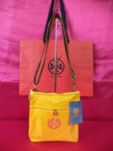

OUR BEST SELLER CLASS A TORY BURCH NYLON SLING BAG (CODE 1206) YELLOW
Category: Bags
Manufacturer: Tory Burch
Price: Php 250.00
NO MINIMUM ORDER REQUIRED

DIMENSIONS:
HEIGHT:8.1 INCHES
WIDTH:8 INCHES

NOTE:TORY BURCH PAPER BAG NOT INCLUDED & NOT FOR SALE
More...
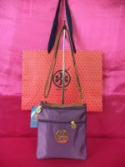

OUR BEST SELLER CLASS A TORY BURCH NYLON SLING BAG (CODE 1206) DARK PURPLE
Category: Bags
Manufacturer: Tory Burch
Price: Php 250.00
NO MINIMUM ORDER REQUIRED

DIMENSIONS:
HEIGHT:8.1 INCHES
WIDTH:8 INCHES

NOTE:TORY BURCH PAPER BAG NOT INCLUDED & NOT FOR SALE
More...
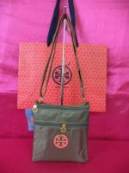

OUR BEST SELLER CLASS A TORY BURCH NYLON SLING BAG (CODE 1206) ARMY GREEN
Category: Bags
Manufacturer: Tory Burch
Price: Php 250.00
NO MINIMUM ORDER REQUIRED

DIMENSIONS:
HEIGHT:8.1 INCHES
WIDTH:8 INCHES

NOTE:TORY BURCH PAPER BAG NOT INCLUDED & NOT FOR SALE
More...
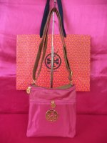

OUR BEST SELLER CLASS A TORY BURCH NYLON SLING BAG (CODE 1206) HOT PINK
Category: Bags
Manufacturer: Tory Burch
Price: Php 250.00
NO MINIMUM ORDER REQUIRED

DIMENSIONS:
HEIGHT:8.1 INCHES
WIDTH:8 INCHES

NOTE:TORY BURCH PAPER BAG NOT INCLUDED & NOT FOR SALE
More...
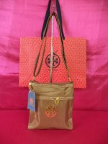

OUR BEST SELLER CLASS A TORY BURCH NYLON SLING BAG (CODE 1206) TAN
Category: Bags
Manufacturer: Tory Burch
Price: Php 250.00
NO MINIMUM ORDER REQUIRED

DIMENSIONS:
HEIGHT:8.1 INCHES
WIDTH:8 INCHES

NOTE:TORY BURCH PAPER BAG NOT INCLUDED & NOT FOR SALE
More...
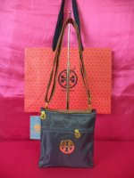

OUR BEST SELLER CLASS A TORY BURCH NYLON SLING BAG (CODE 1206) DARK BLUE
Category: Bags
Manufacturer: Tory Burch
Price: Php 250.00
NO MINIMUM ORDER REQUIRED

DIMENSIONS:
HEIGHT:8.1 INCHES
WIDTH:8 INCHES

NOTE:TORY BURCH PAPER BAG NOT INCLUDED & NOT FOR SALE

More...
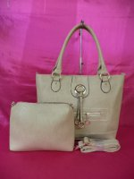

NEW ARRIVALS QUAD A / 4 A NINE WEST 2 IN 1 DRAWSTRING BAG (CODE A40#) (BEIGE)
Category: Bags
Manufacturer: Nine West
Price: Php 550.00
NO MINIMUM ORDER REQUIRED

DESCRIPTION:
- SOFT LEATHERETTE MATERIAL

DIMENSIONS:
HEIGHT:11.9 INCHES
WIDTH:16.1 INCHES
DEPTH:5.3 INCHES

More...
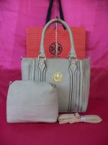

NEW ARRIVALS QUAD A / 4 A TORY BURCH ROBINSON 2 IN 1 BAG (CODE A36) (GRAY)
Category: Bags
Manufacturer: Tory Burch
Price: Php 525.00
NO MINIMUM ORDER REQUIRED

A GLAMOROUS BAG THAT YOU WILL SURELY LOVE :)

DESCRIPTION:
- LEATHERETTE MATERIAL
- WITH EXTRA STRAP

DIMENSIONS:
HEIGHT:11.9 INCHES
WIDTH:15.9 INCHES
DEPTH:4.2 INCHES

NOTE:TORY BURCH PAPER BAG NOT INCLUDED AND NOT FOR SALE
More...
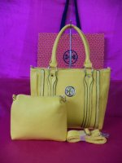

NEW ARRIVALS QUAD A / 4 A TORY BURCH ROBINSON 2 IN 1 BAG (CODE A36) (YELLOW)
Category: Bags
Manufacturer: Tory Burch
Price: Php 525.00
NO MINIMUM ORDER REQUIRED

A GLAMOROUS BAG THAT YOU WILL SURELY LOVE :)

DESCRIPTION:
- LEATHERETTE MATERIAL
- WITH EXTRA STRAP

DIMENSIONS:
HEIGHT:11.9 INCHES
WIDTH:15.9 INCHES
DEPTH:4.2 INCHES

NOTE:TORY BURCH PAPER BAG NOT INCLUDED AND NOT FOR SALE
More...
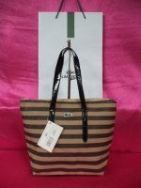

NEW ARRIVALS QUAD A / 4 A LACOSTE HOBO STRIPES (BROWNS & NEUTRALS) CODE 310#
Category: Bags
Manufacturer: Lacoste
Price: Php 550.00
NO MINIMUM ORDER REQUIRED

DIMENSIONS:
HEIGHT:11 INCHES
WIDTH:13.5 INCHES
DEPTH:5.3 INCHES

NOTE:LACOSTE PAPER BAG NOT INCLUDED & NOT FOR SALE
More...
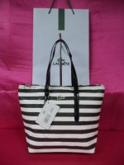

NEW ARRIVALS QUAD A / 4 A LACOSTE HOBO STRIPES (BLACK & WHITE) CODE 310#
Category: Bags
Manufacturer: Lacoste
Price: Php 550.00
NO MINIMUM ORDER REQUIRED

DIMENSIONS:
HEIGHT:11 INCHES
WIDTH:13.5 INCHES
DEPTH:5.3 INCHES

NOTE:LACOSTE PAPER BAG NOT INCLUDED & NOT FOR SALE
More...
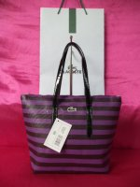

NEW ARRIVALS QUAD A / 4 A LACOSTE HOBO STRIPES (PLUMS & PURPLES) CODE 310#
Category: Bags
Manufacturer: Lacoste
Price: Php 550.00
NO MINIMUM ORDER REQUIRED

DIMENSIONS:
HEIGHT:11 INCHES
WIDTH:13.5 INCHES
DEPTH:5.3 INCHES

NOTE:LACOSTE PAPER BAG NOT INCLUDED & NOT FOR SALE
More...
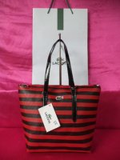

NEW ARRIVALS QUAD A / 4 A LACOSTE HOBO STRIPES (BLACK & RED) CODE 310#
Category: Bags
Manufacturer: Lacoste
Price: Php 550.00
NO MINIMUM ORDER REQUIRED

DIMENSIONS:
HEIGHT:11 INCHES
WIDTH:13.5 INCHES
DEPTH:5.3 INCHES

NOTE:LACOSTE PAPER BAG NOT INCLUDED & NOT FOR SALE
More...
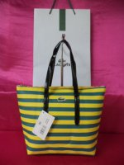

NEW ARRIVALS QUAD A / 4 A LACOSTE HOBO STRIPES (TEALS & YELLOWS) CODE 310#
Category: Bags
Manufacturer: Lacoste
Price: Php 550.00
NO MINIMUM ORDER REQUIRED

DIMENSIONS:
HEIGHT:11 INCHES
WIDTH:13.5 INCHES
DEPTH:5.3 INCHES

NOTE:LACOSTE PAPER BAG NOT INCLUDED & NOT FOR SALE
More...
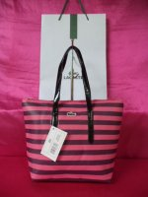

NEW ARRIVALS QUAD A / 4 A LACOSTE HOBO STRIPES (PURPLE & PLUMS) CODE 310#
Category: Bags
Manufacturer: Lacoste
Price: Php 550.00
NO MINIMUM ORDER REQUIRED

DIMENSIONS:
HEIGHT:11 INCHES
WIDTH:13.5 INCHES
DEPTH:5.3 INCHES

NOTE:LACOSTE PAPER BAG NOT INCLUDED & NOT FOR SALE
More...
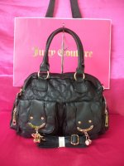

NEW ARRIVALS KOREAN JUICY COUTURE FLORAL & RIBBON SOFT LEATHER HANDBAG WITH EXTRA STRAP (CODE 84030) BLACK
Category: Bags
Manufacturer: Juicy Couture
Price: Php 450.00
NO MINIMUM ORDER REQUIRED

DIMENSIONS:
HEIGHT:11 INCHES
WIDTH:13 INCHES
DEPTH:5.3 INCHES

NOTE:JUICY COUTURE PAPER BAG NOT INCLUDED AND NOT FOR SALE.
More...
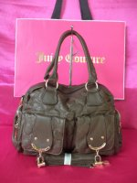

NEW ARRIVALS KOREAN JUICY COUTURE FLORAL & RIBBON SOFT LEATHER HANDBAG WITH EXTRA STRAP (CODE 84030) COFFEE BROWN
Category: Bags
Manufacturer: Juicy Couture
Price: Php 450.00
NO MINIMUM ORDER REQUIRED

DIMENSIONS:
HEIGHT:11 INCHES
WIDTH:13 INCHES
DEPTH:5.3 INCHES

NOTE:JUICY COUTURE PAPER BAG NOT INCLUDED AND NOT FOR SALE.
More...
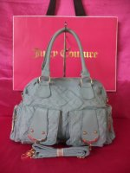

NEW ARRIVALS KOREAN JUICY COUTURE FLORAL & RIBBON SOFT LEATHER HANDBAG WITH EXTRA STRAP (CODE 84030) GRAY
Category: Bags
Manufacturer: Juicy Couture
Price: Php 450.00
NO MINIMUM ORDER REQUIRED

DIMENSIONS:
HEIGHT:11 INCHES
WIDTH:13 INCHES
DEPTH:5.3 INCHES

NOTE:JUICY COUTURE PAPER BAG NOT INCLUDED AND NOT FOR SALE.
More...
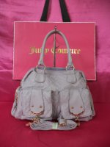

NEW ARRIVALS KOREAN JUICY COUTURE FLORAL & RIBBON SOFT LEATHER HANDBAG WITH EXTRA STRAP (CODE 84030) LILAC
Category: Bags
Manufacturer: Juicy Couture
Price: Php 450.00
NO MINIMUM ORDER REQUIRED

DIMENSIONS:
HEIGHT:11 INCHES
WIDTH:13 INCHES
DEPTH:5.3 INCHES

NOTE:JUICY COUTURE PAPER BAG NOT INCLUDED AND NOT FOR SALE.
More...
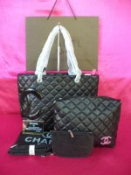

NEW ARRIVALS SUPER AA 7 STAR CHANEL CAMBON PURE BLACK 2 IN 1 SHOULDER BAG (CODE 821#)
Category: Bags
Manufacturer: Chanel
Price: Php 1,500.00
NO MINIMUM ORDER REQUIRED.

DIMENSIONS:
HEIGHT:9.4 INCHES
WIDTH:15.9 INCHES
DEPTH:6.6 INCHES
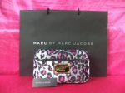

NEW ARRIVALS QUAD A / 4 A MARC JACOBS LIL TATE POUCH (PURPLE CHEETAH)
Category: Bags
Manufacturer: Marc Jacobs
Price: Php 150.00
NO MINIMUM ORDER REQUIRED

DIMENSIONS:
HEIGHT:5.4 INCHES
WIDTH:6.7 INCHES
DEPTH:3.9 INCHES

NOTE:MARC JACOBS PAPER NOT INCLUDED AND NOT FOR SALE
More...
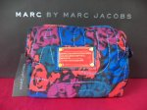

NEW ARRIVALS QUAD A / 4 A MARC JACOBS LIL TATE POUCH (RAINBOW GRAFFITI)
Category: Bags
Manufacturer: Marc Jacobs
Price: Php 150.00
NO MINIMUM ORDER REQUIRED

DIMENSIONS:
HEIGHT:5.4 INCHES
WIDTH:6.7 INCHES
DEPTH:3.9 INCHES

NOTE:MARC JACOBS PAPER NOT INCLUDED AND NOT FOR SALE
More...
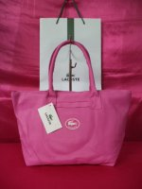

NEW ARRIVALS QUAD A / 4 A LACOSTE LOGO SATCHEL BAG (CODE 1301) FUCHSIA PINK
Category: Bags
Manufacturer: Lacoste
Price: Php 370.00
NO MINIMUM ORDER REQUIRED

DIMENSIONS:
HEIGHT:9.4 INCHES
WIDTH:16.2 INCHES
DEPTH:6 INCHES

NOTE:LACOSTE PAPER BAG IS NOT INCLUDED AND NOT FOR SALE
More...
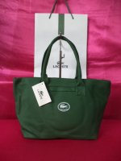

NEW ARRIVALS QUAD A / 4 A LACOSTE LOGO SATCHEL BAG (CODE 1301) DARK GREEN
Category: Bags
Manufacturer: Lacoste
Price: Php 370.00
NO MINIMUM ORDER REQUIRED

DIMENSIONS:
HEIGHT:9.4 INCHES
WIDTH:16.2 INCHES
DEPTH:6 INCHES

NOTE:LACOSTE PAPER BAG IS NOT INCLUDED AND NOT FOR SALE
More...
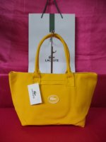

NEW ARRIVALS QUAD A / 4 A LACOSTE LOGO SATCHEL BAG (CODE 1301) YELLOW
Category: Bags
Manufacturer: Lacoste
Price: Php 370.00
NO MINIMUM ORDER REQUIRED

DIMENSIONS:
HEIGHT:9.4 INCHES
WIDTH:16.2 INCHES
DEPTH:6 INCHES

NOTE:LACOSTE PAPER BAG IS NOT INCLUDED AND NOT FOR SALE
More...
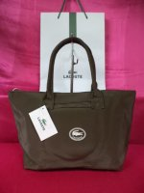

NEW ARRIVALS QUAD A / 4 A LACOSTE LOGO SATCHEL BAG (CODE 1301) DARK BROWN
Category: Bags
Manufacturer: Lacoste
Price: Php 370.00
NO MINIMUM ORDER REQUIRED

DIMENSIONS:
HEIGHT:9.4 INCHES
WIDTH:16.2 INCHES
DEPTH:6 INCHES

NOTE:LACOSTE PAPER BAG IS NOT INCLUDED AND NOT FOR SALE
More...
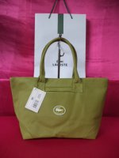

NEW ARRIVALS QUAD A / 4 A LACOSTE LOGO SATCHEL BAG (CODE 1301) APPLE GREEN
Category: Bags
Manufacturer: Lacoste
Price: Php 370.00
NO MINIMUM ORDER REQUIRED

DIMENSIONS:
HEIGHT:9.4 INCHES
WIDTH:16.2 INCHES
DEPTH:6 INCHES

NOTE:LACOSTE PAPER BAG IS NOT INCLUDED AND NOT FOR SALE
More...
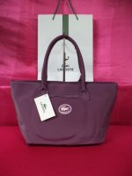

NEW ARRIVALS QUAD A / 4 A LACOSTE LOGO SATCHEL BAG (CODE 1301) PURPLE
Category: Bags
Manufacturer: Lacoste
Price: Php 370.00
NO MINIMUM ORDER REQUIRED

DIMENSIONS:
HEIGHT:9.4 INCHES
WIDTH:16.2 INCHES
DEPTH:6 INCHES

NOTE:LACOSTE PAPER BAG IS NOT INCLUDED AND NOT FOR SALE
More...
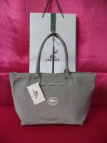

NEW ARRIVALS QUAD A / 4 A LACOSTE LOGO SATCHEL BAG (CODE 1301) GRAY
Category: Bags
Manufacturer: Lacoste
Price: Php 370.00
NO MINIMUM ORDER REQUIRED

DIMENSIONS:
HEIGHT:9.4 INCHES
WIDTH:16.2 INCHES
DEPTH:6 INCHES

NOTE:LACOSTE PAPER BAG IS NOT INCLUDED AND NOT FOR SALE
More...
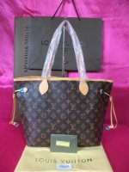

OUR BEST SELLER SUPER AA 8 STAR EURO REPLICA LOUIS VUITTON MONOGRAM CANVAS NEVERFULL MM (CODE M40156)
Category: Bags
Manufacturer: Louis Vuitton
Price: Php 1,500.00
MINIMUM 3 PIECES IN ASSORTED ALBUMS

DIMENSIONS:
HEIGHT:11 INCHES
WIDTH:17 INCHES
DEPTH: 5.4 INCHES

DESCRIPTION:
- OXIDIZED LEATHER
- VERY EXACT COPY
- OXIDIZED LEATHER MATERIAL
- WITH SERIAL NUMBER
- LATEST MODEL & VERY HOT ITEM

INCLUSIONS:
- LOUIS VUITTON HIGH QUALITY DUST BAG
- LOUIS VUITTON CERTIFICATE
More...
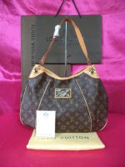

NEW ARRIVALS SUPER AA 8 STAR EURO REPLICA LOUIS VUITTON MONOGRAM CANVAS GALIERRA (CODE M56382)
Category: Bags
Manufacturer: Louis Vuitton
Price: Php 1,750.00
NO MINIMUM ORDER REQUIRED

DIMENSIONS:
HEIGHT:11.9 INCHES
WIDTH:14.8 INCHES
DEPTH:4.1 INCHES

DESCRIPTION:
- OXIDIZED LEATHER
- VERY EXACT COPY
- WITH SERIAL NUMBER
- LATEST MODEL & VERY HOT ITEM

INCLUSIONS:
- LOUIS VUITTON PAPER BAG
- LOUIS VUITTON HIGH QUALITY DUST BAG
- LOUIS VUITTON CERTIFICATE
More...
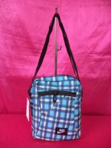

NEW ARRIVALS CLASS A NIKE SLING BAG (CHECKERED BOXES GRAY & BLACK DETAILING) CODE 9231
Category: Bags
Manufacturer: Nike
Price: Php 185.00
MINIMUM 3 PIECES IN ASSORTED ALBUMS

DIMENSIONS:
HEIGHT:10.6 INCHES
WIDTH:8.1 INCHES
DEPTH:3 INCHES
More...
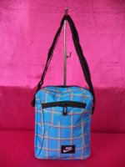

NEW ARRIVALS CLASS A NIKE SLING BAG IN CHECKERED SKY BLUE (CODE 9231)
Category: Bags
Manufacturer: Nike
Price: Php 185.00
MINIMUM 3 PIECES IN ASSORTED ALBUMS

DIMENSIONS:
HEIGHT:10.6 INCHES
WIDTH:8.1 INCHES
DEPTH:3 INCHES
More...
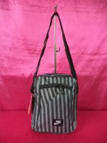

NEW ARRIVALS CLASS A NIKE SLING BAG (BLACK & GRAY STRIPES) CODE 9231
Category: Bags
Manufacturer: Nike
Price: Php 185.00
MINIMUM 3 PIECES IN ASSORTED ALBUMS

DIMENSIONS:
HEIGHT:10.6 INCHES
WIDTH:8.1 INCHES
DEPTH:3 INCHES
More...
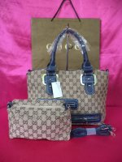

NEW ARRIVALS QUAD A / 4 A GUCCI 2 IN 1 MONOGRAM ZIPPERED BAG (CODE X-714) BLUE
Category: Bags
Manufacturer: Gucci
Price: Php 550.00
MINIMUM 3 PIECES IN ASSORTED ALBUMS

DIMENSIONS:
HEIGHT:9.4 INCHES
WIDTH:16.1 INCHES
DEPTH:6.6 INCHES

INCLUSIONS:
- EXTRA STRAP

NOTE:GUCCI PAPERBAG NOT INCLUDED
More...
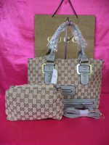

NEW ARRIVALS QUAD A / 4 A GUCCI 2 IN 1 MONOGRAM ZIPPERED BAG (CODE X-714) GRAY
Category: Bags
Manufacturer: Gucci
Price: Php 550.00
MINIMUM 3 PIECES IN ASSORTED ALBUMS

DIMENSIONS:
HEIGHT:9.4 INCHES
WIDTH:16.1 INCHES
DEPTH:6.6 INCHES

INCLUSIONS:
- EXTRA STRAP

NOTE:GUCCI PAPERBAG NOT INCLUDED
More...
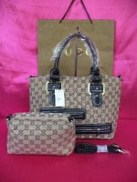

NEW ARRIVALS QUAD A / 4 A GUCCI 2 IN 1 MONOGRAM ZIPPERED BAG (CODE X-714) BLACK
Category: Bags
Manufacturer: Gucci
Price: Php 550.00
MINIMUM 3 PIECES IN ASSORTED ALBUMS

DIMENSIONS:
HEIGHT:9.4 INCHES
WIDTH:16.1 INCHES
DEPTH:6.6 INCHES

INCLUSIONS:
- EXTRA STRAP

NOTE:GUCCI PAPERBAG NOT INCLUDED
More...
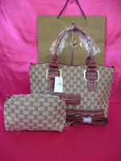

NEW ARRIVALS QUAD A / 4 A GUCCI 2 IN 1 MONOGRAM ZIPPERED BAG (CODE X-714) BURGUNDY
Category: Bags
Manufacturer: Gucci
Price: Php 550.00
MINIMUM 3 PIECES IN ASSORTED ALBUMS

DIMENSIONS:
HEIGHT:9.4 INCHES
WIDTH:16.1 INCHES
DEPTH:6.6 INCHES

INCLUSIONS:
- EXTRA STRAP

NOTE:GUCCI PAPERBAG NOT INCLUDED
More...
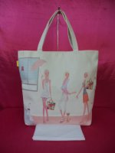

NEW ARRIVALS KOREAN COACH FASHION BAG
Category: Bags
Manufacturer: Korean Bags
Price: Php 300.00
MINIMUM 3 PIECES IN ASSORTED ALBUMS

DIMENSIONS:
HEIGHT:15.9 INCHES
WIDTH:16.2 INCHES
DEPTH:6.5 INCHES
More...
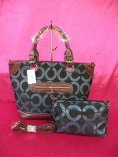

NEW ARRIVALS QUAD A / 4 A COACH 2 IN 1 SATCHEL ZIPPERED BAG (CODE X-711) BLACK/GRAY
Category: Bags
Manufacturer: Coach
Price: Php 550.00
MINIMUM 3 PIECES IN ASSORTED ALBUMS

DIMENSIONS:
HEIGHT:11.9 INCHES
WIDTH:16 INCHES
DEPTH:6 INCHES
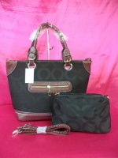

NEW ARRIVALS QUAD A / 4 A COACH 2 IN 1 SATCHEL ZIPPERED BAG (CODE X-711) PURE BLACK
Category: Bags
Manufacturer: Coach
Price: Php 550.00
MINIMUM 3 PIECES IN ASSORTED ALBUMS

DIMENSIONS:
HEIGHT:11.9 INCHES
WIDTH:16 INCHES
DEPTH:6 INCHES
More...
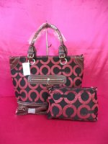

NEW ARRIVALS QUAD A / 4 A COACH 2 IN 1 SATCHEL ZIPPERED BAG (CODE X-711) BLACK/RED
Category: Bags
Manufacturer: Coach
Price: Php 550.00
MINIMUM 3 PIECES IN ASSORTED ALBUMS

DIMENSIONS:
HEIGHT:11.9 INCHES
WIDTH:16 INCHES
DEPTH:6 INCHES
More...
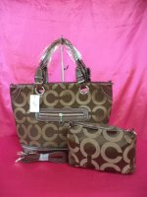

NEW ARRIVALS QUAD A / 4 A COACH 2 IN 1 SATCHEL ZIPPERED BAG (CODE X-711) DARK BROWN
Category: Bags
Manufacturer: Coach
Price: Php 550.00
MINIMUM 3 PIECES IN ASSORTED ALBUMS

DIMENSIONS:
HEIGHT:11.9 INCHES
WIDTH:16 INCHES
DEPTH:6 INCHES
More...
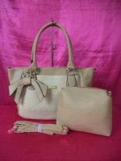

NEW ARRIVALS QUAD A / 4 A NINE WEST FLORAL 2 IN 1 SATCHEL BAG (CODE A31) BEIGE
Category: Bags
Manufacturer: Nine West
Price: Php 550.00
MINIMUM 3 PIECES IN ASSORTED ALBUMS

DIMENSIONS:
HEIGHT:10.6 INCHES
WIDTH:17 INCHES
DEPTH:5.3 INCHES
More...
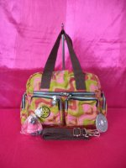

NEW ARRIVALS KIPLING INSPIRATIONAL SHOULDER BAG W/ EXTRA STRAP IN RAINBOW SWIRLS
Category: Bags
Manufacturer: Kipling
Price: Php 280.00
MINIMUM 3 PIECES IN ASSORTED ALBUMS

DIMENSIONS:
HEIGHT:9.4 INCHES
WIDTH:13 INCHES
DEPTH:4.1 INCHES
More...
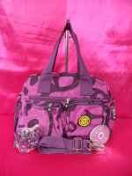

NEW ARRIVALS KIPLING INSPIRATIONAL SHOULDER BAG W/ EXTRA STRAP IN PURPLE SWIRLS
Category: Bags
Manufacturer: Kipling
Price: Php 280.00
MINIMUM 3 PIECES IN ASSORTED ALBUMS

DIMENSIONS:
HEIGHT:9.4 INCHES
WIDTH:13 INCHES
DEPTH:4.1 INCHES
More...
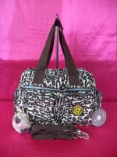

NEW ARRIVALS KIPLING INSPIRATIONAL SHOULDER BAG W/ EXTRA STRAP IN CHEETAH
Category: Bags
Manufacturer: Kipling
Price: Php 280.00
MINIMUM 3 PIECES IN ASSORTED ALBUMS

DIMENSIONS:
HEIGHT:9.4 INCHES
WIDTH:13 INCHES
DEPTH:4.1 INCHES
More...
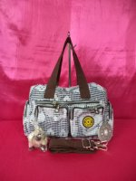

NEW ARRIVALS KIPLING INSPIRATIONAL SHOULDER BAG W/ EXTRA STRAP IN BLACK HEARTS
Category: Bags
Manufacturer: Kipling
Price: Php 280.00
MINIMUM 3 PIECES IN ASSORTED ALBUMS

DIMENSIONS:
HEIGHT:9.4 INCHES
WIDTH:13 INCHES
DEPTH:4.1 INCHES
More...
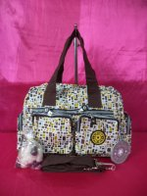

NEW ARRIVALS KIPLING INSPIRATIONAL SHOULDER BAG W/ EXTRA STRAP IN RECTANGULAR COLORS
Category: Bags
Manufacturer: Kipling
Price: Php 280.00
MINIMUM 3 PIECES IN ASSORTED ALBUMS

DIMENSIONS:
HEIGHT:9.4 INCHES
WIDTH:13 INCHES
DEPTH:4.1 INCHES
More...
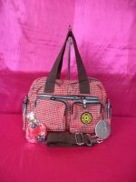

NEW ARRIVALS KIPLING INSPIRATIONAL SHOULDER BAG W/ EXTRA STRAP IN RED HEARTS
Category: Bags
Manufacturer: Kipling
Price: Php 280.00
MINIMUM 3 PIECES IN ASSORTED ALBUMS

DIMENSIONS:
HEIGHT:9.4 INCHES
WIDTH:13 INCHES
DEPTH:4.1 INCHES
More...
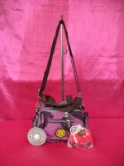

NEW ARRIVALS CLASS A KIPLING PURPLE SWIRLS MINI SLING BAG (CODE 001)
Category: Bags
Manufacturer: Kipling
Price: Php 220.00
NO MINIMUM ORDER REQUIRED

DIMENSIONS:
HEIGHT:5.4 INCHES
WIDTH:8 INCHES
DEPTH:4 INCHES
More...
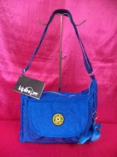

NEW ARRIVALS HIGH QUALITY KIPLING SLING BAG IN ROYAL BLUE
Category: Bags
Manufacturer: Kipling
Price: Php 275.00
NO MINIMUM ORDER REQUIRED

DIMENSIONS:
HEIGHT:9 INCHES
WIDTH:11 INCHES
DEPTH:4 INCHES
More...
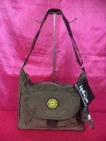

NEW ARRIVALS HIGH QUALITY KIPLING SLING BAG IN BROWN
Category: Bags
Manufacturer: Kipling
Price: Php 275.00
NO MINIMUM ORDER REQUIRED

DIMENSIONS:
HEIGHT:9 INCHES
WIDTH:11 INCHES
DEPTH:4 INCHES
More...
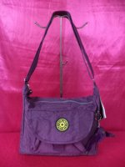

NEW ARRIVALS HIGH QUALITY KIPLING SLING BAG IN PURPLE
Category: Bags
Manufacturer: Kipling
Price: Php 275.00
NO MINIMUM ORDER REQUIRED

DIMENSIONS:
HEIGHT:9 INCHES
WIDTH:11 INCHES
DEPTH:4 INCHES
More...
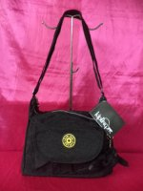

NEW ARRIVALS HIGH QUALITY KIPLING SLING BAG IN BLACK
Category: Bags
Manufacturer: Kipling
Price: Php 275.00
NO MINIMUM ORDER REQUIRED

DIMENSIONS:
HEIGHT:9 INCHES
WIDTH:11 INCHES
DEPTH:4 INCHES
More...
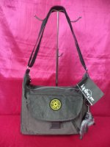

NEW ARRIVALS HIGH QUALITY KIPLING SLING BAG IN GRAY
Category: Bags
Manufacturer: Kipling
Price: Php 275.00
NO MINIMUM ORDER REQUIRED

DIMENSIONS:
HEIGHT:9 INCHES
WIDTH:11 INCHES
DEPTH:4 INCHES
More...
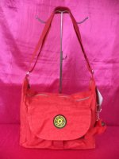

NEW ARRIVALS HIGH QUALITY KIPLING SLING BAG IN RED
Category: Bags
Manufacturer: Kipling
Price: Php 275.00
NO MINIMUM ORDER REQUIRED

DIMENSIONS:
HEIGHT:9 INCHES
WIDTH:11 INCHES
DEPTH:4 INCHES
More...
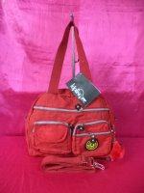

NEW ARRIVALS KIPLING INSPIRATIONAL SHOULDER BAG W/ EXTRA STRAP IN RED
Category: Bags
Manufacturer: Kipling
Price: Php 280.00
NO MINIMUM ORDER REQUIRED

DIMENSIONS:
HEIGHT:9.4 INCHES
WIDTH:13 INCHES
DEPTH:4.1 INCHES
More...
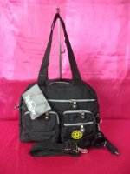

NEW ARRIVALS KIPLING INSPIRATIONAL SHOULDER BAG W/ EXTRA STRAP IN BLACK
Category: Bags
Manufacturer: Kipling
Price: Php 280.00
NO MINIMUM ORDER REQUIRED

DIMENSIONS:
HEIGHT:9.4 INCHES
WIDTH:13 INCHES
DEPTH:4.1 INCHES
More...
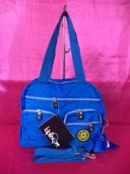

NEW ARRIVALS KIPLING INSPIRATIONAL SHOULDER BAG W/ EXTRA STRAP IN ROYAL BLUE
Category: Bags
Manufacturer: Kipling
Price: Php 280.00
NO MINIMUM ORDER REQUIRED

DIMENSIONS:
HEIGHT:9.4 INCHES
WIDTH:13 INCHES
DEPTH:4.1 INCHES
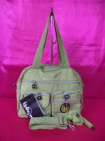

NEW ARRIVALS KIPLING INSPIRATIONAL SHOULDER BAG W/ EXTRA STRAP IN APPLE GREEN
Category: Bags
Manufacturer: Kipling
Price: Php 280.00
NO MINIMUM ORDER REQUIRED

DIMENSIONS:
HEIGHT:9.4 INCHES
WIDTH:13 INCHES
DEPTH:4.1 INCHES
More...
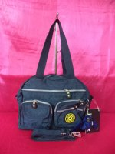

NEW ARRIVALS KIPLING INSPIRATIONAL SHOULDER BAG W/ EXTRA STRAP IN DARK BLUE
Category: Bags
Manufacturer: Kipling
Price: Php 280.00
NO MINIMUM ORDER REQUIRED

DIMENSIONS:
HEIGHT:9.4 INCHES
WIDTH:13 INCHES
DEPTH:4.1 INCHES
More...
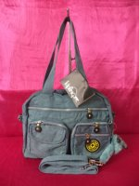

NEW ARRIVALS KIPLING INSPIRATIONAL SHOULDER BAG W/ EXTRA STRAP IN GRAY
Category: Bags
Manufacturer: Kipling
Price: Php 280.00
NO MINIMUM ORDER REQUIRED

DIMENSIONS:
HEIGHT:9.4 INCHES
WIDTH:13 INCHES
DEPTH:4.1 INCHES
More...
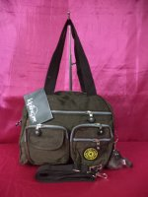

NEW ARRIVALS KIPLING INSPIRATIONAL SHOULDER BAG W/ EXTRA STRAP IN BROWN
Category: Bags
Manufacturer: Kipling
Price: Php 280.00
NO MINIMUM ORDER REQUIRED

DIMENSIONS:
HEIGHT:9.4 INCHES
WIDTH:13 INCHES
DEPTH:4.1 INCHES
More...
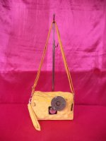

NEW ARRIVALS QUAD A / 4 A KIPLING MINI SLING BAG (CODE 20167) YELLOW
Category: Bags
Manufacturer: Kipling
Price: Php 220.00
MINIMUM 3 PIECES IN ASSORTED ALBUMS

DIMENSIONS:
HEIGHT:6 INCHES
WIDTH:9.3 INCHES
DEPTH:3 INCHES
More...
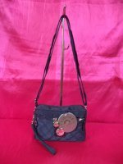

NEW ARRIVALS QUAD A / 4 A KIPLING MINI SLING BAG (CODE 20167) DARK BLUE
Category: Bags
Manufacturer: Kipling
Price: Php 0.00
MINIMUM 3 PIECES IN ASSORTED ALBUMS

DIMENSIONS:
HEIGHT:6 INCHES
WIDTH:9.3 INCHES
DEPTH:3 INCHES
More...
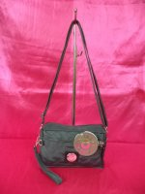

NEW ARRIVALS QUAD A / 4 A KIPLING MINI SLING BAG (CODE 20167) GRAY
Category: Bags
Manufacturer: Kipling
Price: Php 220.00
MINIMUM 3 PIECES IN ASSORTED ALBUMS

DIMENSIONS:
HEIGHT:6 INCHES
WIDTH:9.3 INCHES
DEPTH:3 INCHES
More...
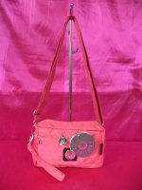

NEW ARRIVALS QUAD A / 4 A KIPLING MINI SLING BAG (CODE 20167) CARNATION PINK
Category: Bags
Manufacturer: Kipling
Price: Php 220.00
MINIMUM 3 PIECES IN ASSORTED ALBUMS

DIMENSIONS:
HEIGHT:6 INCHES
WIDTH:9.3 INCHES
DEPTH:3 INCHES
More...
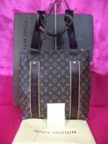

NEW ARRIVALS SUPER AA 8 STAR EURO REPLICA LOUIS VUITTON MONOGRAM CANVAS BEAUBORG UNISEX SHOULDER BAG (CODE M52006)
Category: Bags
Manufacturer: Louis Vuitton
Price: Php 1,500.00
MINIMUM 3 PIECES IN ASSORTED ALBUMS

DIMENSIONS:
HEIGHT:14.6 INCHES
WIDTH:14.6 INCHES
DEPTH:3.8 INCHES

DESCRIPTION:
GENUINE LEATHER
OXIDIZED LEATHER
HIGHEST REPLICA
WITH SERIAL NUMBER

INCLUSIONS:
LOUIS VUITTON CERTIFICATE
LOUIS VUITTON DUST BAG
LOUIS VUITTON PAPERBAG

NOTE:LOUIS VUITTON BOX NOT INCLUDED
More...
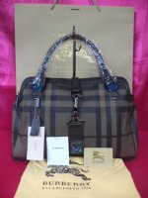

NEW ARRIVALS SUPER AA 8 STAR EURO REPLICA BURBERRY SMOKE CHECK SATCHEL BAG (CODE A1871)
Category: Bags
Manufacturer: Burberry
Price: Php 4,500.00
NO MINIMUM ORDER REQUIRED

DESCRIPTION:
PURE GENUINE LEATHER
WITH SOFT LEATHER TRIM

DIMENSIONS:
HEIGHT:11 INCHES
WIDTH:15 INCHES
DEPTH:6.6 INCHES
INCLUSIONS:
BURBERRY DUST BAG
BURBERRY PAPERBAG
BURBERRY CERTIFICATE

More...
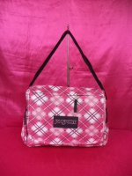

NEW ARRIVALS CLASS A JANSPORT MESSENGER (UNISEX) SLING BAG (CODE 1001) CHECKERED PINK
Category: Bags
Manufacturer: Jansport
Price: Php 330.00
MINIMUM 3 PIECES IN ASSORTED ALBUMS

DIMENSIONS:
HEIGHT:10.7 INCHES
WIDTH:13.4 INCHES
DEPTH:4 INCHES
More...
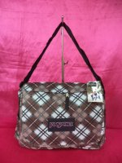

NEW ARRIVALS CLASS A JANSPORT MESSENGER (UNISEX) SLING BAG (CODE 1001) CHECKERED BROWN
Category: Bags
Manufacturer: Jansport
Price: Php 330.00
MINIMUM 3 PIECES IN ASSORTED ALBUMS

DIMENSIONS:
HEIGHT:10.7 INCHES
WIDTH:13.4 INCHES
DEPTH:4 INCHES
More...
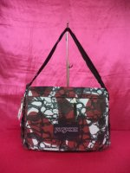

NEW ARRIVALS CLASS A JANSPORT MESSENGER (UNISEX) SLING BAG (CODE 1001) FLORAL ABSTRACT MAROON
Category: Bags
Manufacturer: Jansport
Price: Php 330.00
MINIMUM 3 PIECES IN ASSORTED ALBUMS

DIMENSIONS:
HEIGHT:10.7 INCHES
WIDTH:13.4 INCHES
DEPTH:4 INCHES
More...
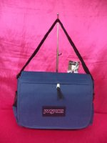

NEW ARRIVALS CLASS A JANSPORT MESSENGER (UNISEX) SLING BAG (CODE 1001) DARK BLUE
Category: Bags
Manufacturer: Jansport
Price: Php 330.00
MINIMUM 3 PIECES IN ASSORTED ALBUMS

DIMENSIONS:
HEIGHT:10.7 INCHES
WIDTH:13.4 INCHES
DEPTH:4 INCHES
More...
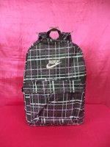

NEW ARRIVALS CLASS A NIKE KNAPSACK (PURPLE LINES)
Category: Bags
Manufacturer: Nike
Price: Php 300.00
MINIMUM 3 PIECES IN ASSORTED ALBUMS

DIMENSIONS:
HEIGHT:16 INCHES
WIDTH:11.9 INCHES
DEPTH:5.3 INCHES
More...
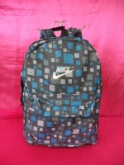

NEW ARRIVALS CLASS A NIKE KNAPSACK (SEVERAL BLUE SQUARES)
Category: Bags
Manufacturer: Nike
Price: Php 300.00
MINIMUM 3 PIECES IN ASSORTED ALBUMS

DIMENSIONS:
HEIGHT:16 INCHES
WIDTH:11.9 INCHES
DEPTH:5.3 INCHES
More...
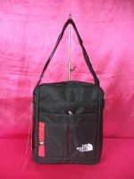

NEW ARRIVALS QUAD A /4 A NORTH FACE SLING BAG (CODE 0115)
Category: Bags
Manufacturer: North Face
Price: Php 420.00
MINIMUM 3 PIECES IN ASSORTED ALBUMS

DIMENSIONS:
HEIGHT:12 INCHES
WIDTH:10 INCHES
DEPTH:3.9 INCHES
More...
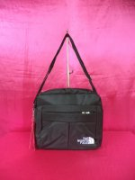

NEW ARRIVALS QUAD A /4 A NORTH FACE SLING BAG (CODE 8308)
Category: Bags
Manufacturer: North Face
Price: Php 420.00
MINIMUM 3 PIECES IN ASSORTED ALBUMS

DIMENSIONS:
HEIGHT:12 INCHES
WIDTH:12.2 INCHES
DEPTH:3.9 INCHES
More...
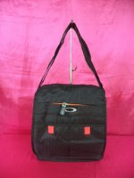

NEW ARRIVALS QUAD A / 4 A OAKLEY MESSENGER BAG (CODE 0109-01)
Category: Bags
Manufacturer: Oakley
Price: Php 420.00
MINIMUM 3 PIECES IN ASSORTED ALBUMS

DIMENSIONS:
HEIGHT:12.2 INCHES
WIDTH:10.6 INCHES
DEPTH:3.9 INCHES
More...
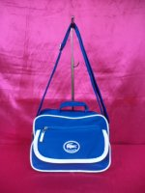

NEW ARRIVALS CLASS A LACOSTE CLASSIC 2 IN 1 SLING BAG (CODE 114) ROYAL BLUE
Category: Bags
Manufacturer: Lacoste
Price: Php 250.00
MINIMUM 3 PIECES IN ASSORTED ALBUMS

DIMENSIONS:
HEIGHT:8.1 INCHES
WIDTH:10.7 INCHES
DEPTH:5 INCHES
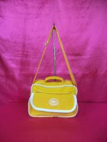

NEW ARRIVALS CLASS A LACOSTE CLASSIC 2 IN 1 SLING BAG (CODE 114) YELLOW
Category: Bags
Manufacturer: Lacoste
Price: Php 250.00
MINIMUM 3 PIECES IN ASSORTED ALBUMS

DIMENSIONS:
HEIGHT:8.1 INCHES
WIDTH:10.7 INCHES
DEPTH:5 INCHES
More...
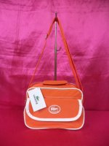

NEW ARRIVALS CLASS A LACOSTE CLASSIC 2 IN 1 SLING BAG (CODE 114) ORANGE
Category: Bags
Manufacturer: Lacoste
Price: Php 250.00
MINIMUM 3 PIECES IN ASSORTED ALBUMS

DIMENSIONS:
HEIGHT:8.1 INCHES
WIDTH:10.7 INCHES
DEPTH:5 INCHES
More...
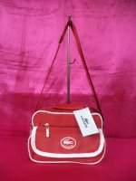

NEW ARRIVALS CLASS A LACOSTE CLASSIC 2 IN 1 SLING BAG (CODE 114) RED
Category: Bags
Manufacturer: Lacoste
Price: Php 250.00
MINIMUM 3 PIECES IN ASSORTED ALBUMS

DIMENSIONS:
HEIGHT:8.1 INCHES
WIDTH:10.7 INCHES
DEPTH:5 INCHES
More...
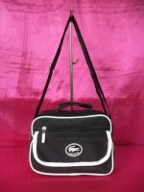

NEW ARRIVALS CLASS A LACOSTE CLASSIC 2 IN 1 SLING BAG (CODE 114) BLACK
Category: Bags
Manufacturer: Lacoste
Price: Php 250.00
MINIMUM 3 PIECES IN ASSORTED ALBUMS

DIMENSIONS:
HEIGHT:8.1 INCHES
WIDTH:10.7 INCHES
DEPTH:5 INCHES
More...
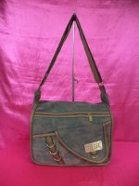

NEW ARRIVALS CLASS A DIESEL DENIM UNISEX SLING BAG (SLANT LINE))
Category: Bags
Manufacturer: Diesel
Price: Php 310.00
MINIMUM 3 PIECES IN ASSORTED ALBUMS

DIMENSIONS:
HEIGHT:11.9 INCHES
WIDTH:13 INCHES
DEPTH:4.1 INCHES
More...
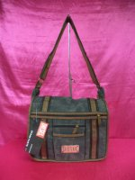

NEW ARRIVALS CLASS A DIESEL DENIM UNISEX SLING BAG (STRAIGHT 2 LINES)
Category: Bags
Manufacturer: Diesel
Price: Php 310.00
MINIMUM 3 PIECES IN ASSORTED ALBUMS

DIMENSIONS:
HEIGHT:11.9 INCHES
WIDTH:13 INCHES
DEPTH:4.1 INCHES
More...
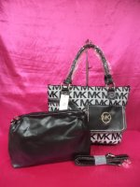

NEW ARRIVALS QUAD A / 4 A MICHAEL KORS MONOGRAM 2 IN 1 WITH FRONT POCKET BAG (CODE 504#) BLACK
Category: Bags
Manufacturer: Michael Kors
Price: Php 550.00
MINIMUM 3 PIECES IN ASSORTED ALBUMS

DIMENSIONS:
HEIGHT:10.7 INCHES
WIDTH:15.9 INCHES
DEPTH:5.4 INCHES

DESCRIPTION:
MADE OF CANVAS/LEATHERETTE MATERIAL
More...
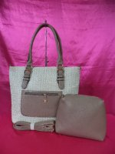

NEW ARRIVALS QUAD A / 4 A NINE WEST RUFFLES 2 IN 1 SHOULDER BAG (CODE A56) GRAY
Category: Bags
Manufacturer: Nine West
Price: Php 550.00
MINIMUM 3 PIECES IN ASSORTED ALBUMS

DIMENSIONS:
HEIGHT:12.2 INCHES
WIDTH:16 INCHES
DEPTH:6 INCHES
More...
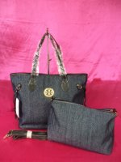

NEW ARRIVALS QUAD A / 4 A TORY BURCH NEVERFULL DENIM 2 IN 1 BAG (CODE 6831#) BLACK
Category: Bags
Manufacturer: Tory Burch
Price: Php 550.00
MINIMUM 3 PIECES IN ASSORTED ALBUMS

DIMENSIONS:
HEIGHT:11.9 INCHES
WIDTH:15.9 INCHES
DEPTH:7.8 INCHES
More...
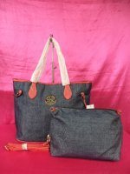

NEW ARRIVALS QUAD A / 4 A TORY BURCH NEVERFULL DENIM 2 IN 1 BAG (CODE 6831#) RED
Category: Bags
Manufacturer: Tory Burch
Price: Php 550.00
MINIMUM 3 PIECES IN ASSORTED ALBUMS

DIMENSIONS:
HEIGHT:11.9 INCHES
WIDTH:15.9 INCHES
DEPTH:7.8 INCHES
More...
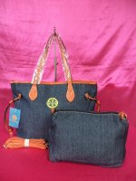

NEW ARRIVALS QUAD A / 4 A TORY BURCH NEVERFULL DENIM 2 IN 1 BAG (CODE 6831#) ORANGE
Category: Bags
Manufacturer: Tory Burch
Price: Php 550.00
MINIMUM 3 PIECES IN ASSORTED ALBUMS

DIMENSIONS:
HEIGHT:11.9 INCHES
WIDTH:15.9 INCHES
DEPTH:7.8 INCHES
More...
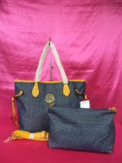

NEW ARRIVALS QUAD A / 4 A TORY BURCH NEVERFULL DENIM 2 IN 1 BAG (CODE 6831#) YELLOW
Category: Bags
Manufacturer: Tory Burch
Price: Php 550.00
MINIMUM 3 PIECES IN ASSORTED ALBUMS

DIMENSIONS:
HEIGHT:11.9 INCHES
WIDTH:15.9 INCHES
DEPTH:7.8 INCHES
More...
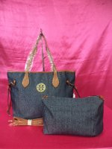

NEW ARRIVALS QUAD A / 4 A TORY BURCH NEVERFULL DENIM 2 IN 1 BAG (CODE 6831#) TAN
Category: Bags
Manufacturer: Tory Burch
Price: Php 550.00
MINIMUM 3 PIECES IN ASSORTED ALBUMS

DIMENSIONS:
HEIGHT:11.9 INCHES
WIDTH:15.9 INCHES
DEPTH:7.8 INCHES
More...
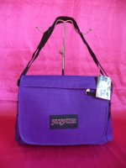

OUR BEST SELLER CLASS A JANSPORT MESSENGER (UNISEX) SLING BAG (CODE 1001) PURPLE
Category: Bags
Manufacturer: Jansport
Price: Php 330.00
MINIMUM 3 PIECES IN ASSORTED ALBUMS

DIMENSIONS:
HEIGHT:10.7 INCHES
WIDTH:13.4 INCHES
DEPTH:4 INCHES
More...
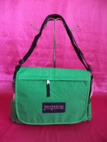

NEW ARRIVALS CLASS A JANSPORT MESSENGER (UNISEX) SLING BAG (CODE 1001) GREEN
Category: Bags
Manufacturer: Jansport
Price: Php 330.00
MINIMUM 3 PIECES IN ASSORTED ALBUMS

DIMENSIONS:
HEIGHT:10.7 INCHES
WIDTH:13.4 INCHES
DEPTH:4 INCHES
More...
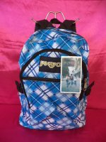

NEW ARRIVALS CLASS A JANSPORT LOW QUALITY (FULL CHECKERED BLUE) CODE 017
Category: Bags
Manufacturer: Jansport
Price: Php 220.00
MINIMUM 3 PIECES IN ASSORTED ALBUMS

DIMENSIONS:
HEIGHT:12.2 INCHES
WIDTH:8 INCHES
DEPTH:4.1 INCHES
More...
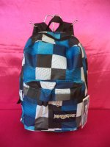

NEW ARRIVALS CLASS A JANSPORT LOW QUALITY (BLUE SQUARES) CODE 017
Category: Bags
Manufacturer: Jansport
Price: Php 220.00
MINIMUM 3 PIECES IN ASSORTED ALBUMS

DIMENSIONS:
HEIGHT:12.2 INCHES
WIDTH:8 INCHES
DEPTH:4.1 INCHES
More...
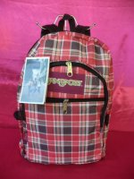

NEW ARRIVALS CLASS A JANSPORT LOW QUALITY (PLAID RED) CODE 017
Category: Bags
Manufacturer: Jansport
Price: Php 220.00
MINIMUM 3 PIECES IN ASSORTED ALBUMS

DIMENSIONS:
HEIGHT:12.2 INCHES
WIDTH:8 INCHES
DEPTH:4.1 INCHES
More...
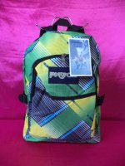

NEW ARRIVALS CLASS A JANSPORT LOW QUALITY (STRIKE GREEN) CODE 017
Category: Bags
Manufacturer: Jansport
Price: Php 220.00
MINIMUM 3 PIECES IN ASSORTED ALBUMS

DIMENSIONS:
HEIGHT:12.2 INCHES
WIDTH:8 INCHES
DEPTH:4.1 INCHES
More...
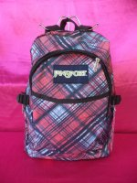

NEW ARRIVALS CLASS A JANSPORT LOW QUALITY (DOUBLE CHECKERS) CODE 017
Category: Bags
Manufacturer: Jansport
Price: Php 220.00
MINIMUM 3 PIECES IN ASSORTED ALBUMS

DIMENSIONS:
HEIGHT:16 INCHES
WIDTH:12 INCHES
DEPTH:4.1 INCHES
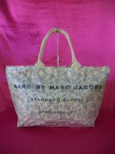

NEW ARRIVALS CLASS A MARC JACOBS WATERPROOF SATCHEL BAG (FLORAL YELLOW) CODE 0221.61 GM SIZE
Category: Bags
Manufacturer: Marc Jacobs
Price: Php 395.00
MINIMUM 3 PIECES IN ASSORTED ALBUMS

DIMENSIONS:
HEIGHT:13.5 INCHES
WIDTH:21.5 INCHES
DEPTH:7.9 INCHES
More...
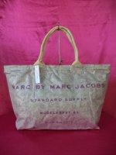

NEW ARRIVALS CLASS A MARC JACOBS WATERPROOF SATCHEL BAG (FLORAL GRAY) CODE 0221.61 GM SIZE
Category: Bags
Manufacturer: Marc Jacobs
Price: Php 395.00
MINIMUM 3 PIECES IN ASSORTED ALBUMS

DIMENSIONS:
HEIGHT:13.5 INCHES
WIDTH:21.5 INCHES
DEPTH:7.9 INCHES
More...
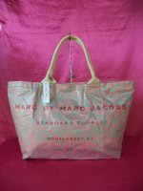

NEW ARRIVALS CLASS A MARC JACOBS WATERPROOF SATCHEL BAG (FLORAL RED) CODE 0221.61 GM SIZE
Category: Bags
Manufacturer: Marc Jacobs
Price: Php 395.00
MINIMUM 3 PIECES IN ASSORTED ALBUMS

DIMENSIONS:
HEIGHT:13.5 INCHES
WIDTH:21.5 INCHES
DEPTH:7.9 INCHES
More...
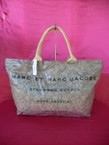

NEW ARRIVALS CLASS A MARC JACOBS WATERPROOF SATCHEL BAG (FLORAL BLACK) CODE 0221.61 GM SIZE
Category: Bags
Manufacturer: Marc Jacobs
Price: Php 395.00
MINIMUM 3 PIECES IN ASSORTED ALBUMS

DIMENSIONS:
HEIGHT:13.5 INCHES
WIDTH:21.5 INCHES
DEPTH:7.9 INCHES
More...
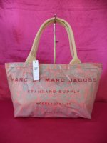

NEW ARRIVALS CLASS A MARC JACOBS WATERPROOF SATCHEL BAG (FLORAL RED) CODE 0221.60 MM
Category: Bags
Manufacturer: Marc Jacobs
Price: Php 375.00
MINIMUM 3 PIECES IN ASSORTED ALBUMS

DIMENSIONS:
HEIGHT:10 INCHES
WIDTH:16 INCHES
DEPTH:5.4 INCHES
More...
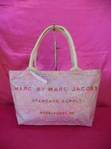

NEW ARRIVALS CLASS A MARC JACOBS WATERPROOF SATCHEL BAG (FLORAL PINK) CODE 0221.60 MM SIZE
Category: Bags
Manufacturer: Marc Jacobs
Price: Php 375.00
MINIMUM 3 PIECES IN ASSORTED ALBUMS

DIMENSIONS:
HEIGHT:10 INCHES
WIDTH:16 INCHES
DEPTH:5.4 INCHES
More...
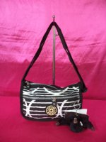

NEW ARRIVALS CLASS A KIPLING MINI SLING BAG (CODE 8952) ZEBRA BLACK/WHITE
Category: Bags
Manufacturer: Kipling
Price: Php 300.00
MINIMUM 3 PIECES IN ASSORTED ALBUMS

DIMENSIONS:
HEIGHT:7.8 INCHES
WIDTH:8 INCHES
DEPTH:3 INCHES
More...
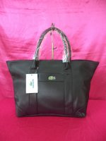

OUR BEST SELLER SUPER AA 8 STAR EURO REPLICA LACOSTE SHOULDER BAG WITH ONE POCKET (CODE 988) BLACK
Category: Bags
Manufacturer: Lacoste
Price: Php 950.00
MINIMUM 3 PIECES IN ASSORTED ALBUMS

DIMENSIONS:
HEIGHT:12 INCHES
WIDTH:17.5 INCHES
DEPTH:6.7 INCHES
More...
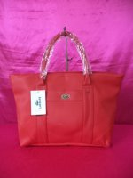

OUR BEST SELLER SUPER AA 8 STAR EURO REPLICA LACOSTE SHOULDER BAG WITH ONE POCKET (CODE 988) RED
Category: Bags
Manufacturer: Lacoste
Price: Php 950.00
MINIMUM 3 PIECES IN ASSORTED ALBUMS

DIMENSIONS:
HEIGHT:12 INCHES
WIDTH:17.5 INCHES
DEPTH:6.7 INCHES
More...
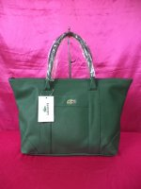

OUR BEST SELLER SUPER AA 8 STAR EURO REPLICA LACOSTE SHOULDER BAG WITH ONE POCKET (CODE 988) ARMY GREEN
Category: Bags
Manufacturer: Lacoste
Price: Php 950.00
MINIMUM 3 PIECES IN ASSORTED ALBUMS

DIMENSIONS:
HEIGHT:12 INCHES
WIDTH:17.5 INCHES
DEPTH:6.7 INCHES
More...
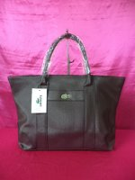

OUR BEST SELLER SUPER AA 8 STAR EURO REPLICA LACOSTE SHOULDER BAG WITH ONE POCKET (CODE 988) COFFEE
Category: Bags
Manufacturer: Lacoste
Price: Php 950.00
MINIMUM 3 PIECES IN ASSORTED ALBUMS

DIMENSIONS:
HEIGHT:12 INCHES
WIDTH:17.5 INCHES
DEPTH:6.7 INCHES
More...
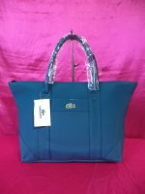

OUR BEST SELLER SUPER AA 8 STAR EURO REPLICA LACOSTE SHOULDER BAG WITH ONE POCKET (CODE 988) COBALT BLUE
Category: Bags
Manufacturer: Lacoste
Price: Php 950.00
MINIMUM 3 PIECES IN ASSORTED ALBUMS

DIMENSIONS:
HEIGHT:12 INCHES
WIDTH:17.5 INCHES
DEPTH:6.7 INCHES
More...
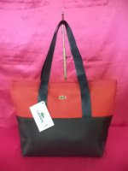

NEW ARRIVALS CLASS A LACOSTE SATCHEL TWO TONED BAG (CODE D-04) RED/BLACK
Category: Bags
Manufacturer: Lacoste
Price: Php 350.00
MINIMUM 3 PIECES IN ASSORTED ALBUMS

DIMENSIONS:
HEIGHT:11.8 INCHES
WIDTH:15 INCHES
DEPTH:5.4 INCHES
More...
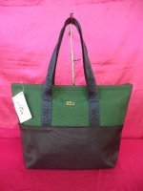

NEW ARRIVALS CLASS A LACOSTE SATCHEL TWO TONED BAG (CODE D-04) ARMY GREEN/BLACK
Category: Bags
Manufacturer: Lacoste
Price: Php 350.00
MINIMUM 3 PIECES IN ASSORTED ALBUMS

DIMENSIONS:
HEIGHT:11.8 INCHES
WIDTH:15 INCHES
DEPTH:5.4 INCHES
More...
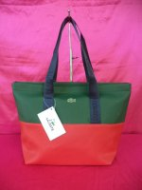

NEW ARRIVALS CLASS A LACOSTE SATCHEL TWO TONED BAG (CODE D-04) ARMY GREEN/RED
Category: Bags
Manufacturer: Lacoste
Price: Php 350.00
MINIMUM 3 PIECES IN ASSORTED ALBUMS

DIMENSIONS:
HEIGHT:11.8 INCHES
WIDTH:15 INCHES
DEPTH:5.4 INCHES
More...
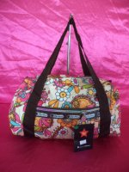

NEW ARRIVALS CLASS A LE SPORT SAC DUFFLE BAG (FLORALS)
Category: Bags
Manufacturer: Le Sport Sac
Price: Php 250.00
MINIMUM 3 PIECES IN ASSORTED ALBUMS

DIMENSIONS:
HEIGHT:13.4 INCHES
WIDTH:11.9 INCHES
DEPTH:6 INCHES
More...
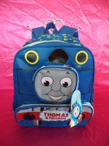

NEW ARRIVALS CLASS A THOMAS & FRIENDS SCHOOL BAG (BIG) CODE 925
Category: Bags
Manufacturer: Others
Price: Php 350.00
MINIMUM 3 PIECES IN ASSORTED ALBUMS

DIMENSIONS:
HEIGHT:12.1 INCHES
WIDTH:10.6 INCHES
DEPTH:4.1 INCHES

GREAT FOR SCHOOL BAG :)
More...
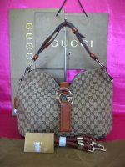

NEW ARRIVALS SUPER AA 7 STAR GUCCI MONOGRAM G WAVE MEDIUM (CODE 232931)
Category: Bags
Manufacturer: Gucci
Price: Php 1,750.00
MINIMUM 3 PIECES IN ASSORTED ALBUMS

DIMENSIONS:
HEIGHT:11.9 INCHES
WIDTH:15.9 INCHES
DEPTH:3.9 INCHES
More...
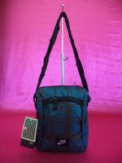

NEW ARRIVALS CLASS A NIKE SLING BAG (GINGHAM BLUE GRAY) CODE 118162
Category: Bags
Manufacturer: Nike
Price: Php 185.00
MINIMUM 3 PIECES IN ASSORTED ALBUMS

DIMENSIONS:
HEIGHT:9.3 INCHES
WIDTH:7.9 INCHES
DEPTH:3 INCHES
More...
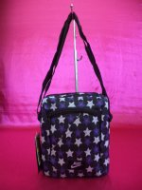

NEW ARRIVALS CLASS A NIKE SLING BAG (PURPLE STARS)) CODE 118162
Category: Bags
Manufacturer: Nike
Price: Php 185.00
MINIMUM 3 PIECES IN ASSORTED ALBUMS

DIMENSIONS:
HEIGHT:9.3 INCHES
WIDTH:7.9 INCHES
DEPTH:3 INCHES
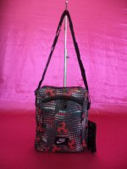

NEW ARRIVALS CLASS A NIKE SLING BAG (ARROW RED) CODE 118162
Category: Bags
Manufacturer: Nike
Price: Php 185.00
MINIMUM 3 PIECES IN ASSORTED ALBUMS

DIMENSIONS:
HEIGHT:9.3 INCHES
WIDTH:7.9 INCHES
DEPTH:3 INCHES
More...
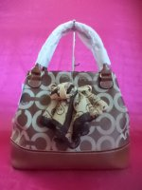

NEW ARRIVALS QUAD A / 4 A COACH POSITANO SHOULDER BAG (BROWN) CODE 3313
Category: Bags
Manufacturer: Coach
Price: Php 650.00
MINIMUM 3 PIECES IN ASSORTED ALBUMS

DIMENSIONS:
HEIGHT:12.2 INCHES
WIDTH:13.4 INCHES
DEPTH:6.5 INCHES
More...
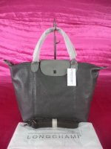

OUR BEST SELLER SUPER AA 7 STAR LONGCHAMP LE PLIAGE FOLDING BAG IN SOFT LEATHER (GRAY COLOR) CODE #420
Category: Bags
Manufacturer: Longchamp
Price: Php 695.00
MINIMUM 3 PIECES IN ASSORTED ALBUMS

DIMENSIONS:
HEIGHT:11.8 INCHES
WIDTH:14.7 INCHES
DEPTH:7 INCHES
More...
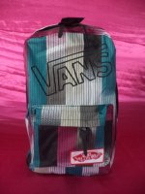

NEW ARRIVALS CLASS A VANS KNAPSACK (COLORED LINES BLUE/GREEN/ MAGENTA) CODE 2828
Category: Bags
Manufacturer: Vans
Price: Php 320.00
MINIMUM 3 PIECES IN ASSORTED ALBUMS

DIMENSIONS:
HEIGHT:16.2 INCHES
WIDTH:12 INCHES
DEPTH:6.5 INCHES
More...
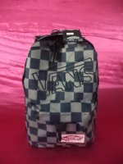

NEW ARRIVALS CLASS A VANS KNAPSACK (BLUE/GRAY CHECKERS) CODE 2828
Category: Bags
Manufacturer: Vans
Price: Php 320.00
MINIMUM 3 PIECES IN ASSORTED ALBUMS

DIMENSIONS:
HEIGHT:16.2 INCHES
WIDTH:12 INCHES
DEPTH:6.5 INCHES
More...
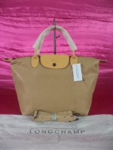

OUR BEST SELLER SUPER AA 7 STAR LONGCHAMP LE PLIAGE FOLDING BAG IN SOFT LEATHER (BEIGE COLOR) CODE #420
Category: Bags
Manufacturer: Longchamp
Price: Php 695.00
MINIMUM 3 PIECES IN ASSORTED ALBUMS

DIMENSIONS:
HEIGHT:11.8 INCHES
WIDTH:14.7 INCHES
DEPTH:7 INCHES
More...
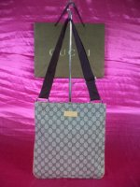

OUR BEST SELLER CLASS A GUCCI MONOGRAM SLING BAG APRICOT COLOR (CODE 201446)
Category: Bags
Manufacturer: Gucci
Price: Php 350.00
MINIMUM 3 PIECES IN ASSORTED ALBUMS

DIMENSIONS:
HEIGHT:12 INCHES
WIDTH:11.8 INCHES
More...
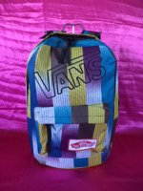

NEW ARRIVALS CLASS A VANS KNAPSACK (COLORED LINES) CODE 2828
Category: Bags
Manufacturer: Vans
Price: Php 320.00
MINIMUM 3 PIECES IN ASSORTED ALBUMS

DIMENSIONS:
HEIGHT:16.2 INCHES
WIDTH:12 INCHES
DEPTH:6.5 INCHES
More...
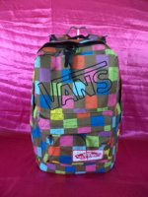

NEW ARRIVALS CLASS A VANS KNAPSACK (COLORED CHECKERES) CODE 2828
Category: Bags
Manufacturer: Vans
Price: Php 320.00
MINIMUM 3 PIECES IN ASSORTED ALBUMS

DIMENSIONS:
HEIGHT:16.2 INCHES
WIDTH:12 INCHES
DEPTH:6.5 INCHES
More...
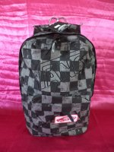

NEW ARRIVALS CLASS A VANS KNAPSACK (BLACK/GRAY CHECKERS) CODE 2828
Category: Bags
Manufacturer: Vans
Price: Php 320.00
MINIMUM 3 PIECES IN ASSORTED ALBUMS

DIMENSIONS:
HEIGHT:16.2 INCHES
WIDTH:12 INCHES
DEPTH:6.5 INCHES
More...
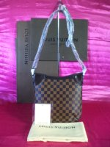

OUR BEST SELLER SUPER AA 8 STAR EURO REPLICA LOUIS VUITTON DAMIER EBENE ODEON (CODE N56390)
Category: Bags
Manufacturer: Louis Vuitton
Price: Php 1,500.00
MINIMUM 3 PIECES IN ASSORTED ALBUMS

